SS

Elmsett Parish Council

.. b

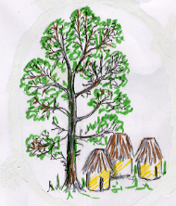

I HEREBY GIVE YOU NOTICE OF THE NEXT MEETING OF ELMSETT PARISH COUNCIL TO BE HELD ON

Tuesday 7 April 2026
7.00 pm

ELMSETT VILLAGE HALL

Signed: Kathleen Peacock
Clerk
- Apologies

- Minutes of the meeting held on 24 February 2026

- Declarations of Interest

- Correspondence

- Casual Vacancy

- Recess for Public Comments

- Planning

- Discharge of Conditions Application for DC/25/01016 - Conditions 5 (Lime render Materials) and 6 (Windows). Address: Elm Farm, Whatfield Road, Elmsett, IP7 6LS. Application No: DC/26/01209

- Householder Application - Erection of a single storey rear extension and front porch canopy extension. Weatherboarding to all elevations of the property.
Address; Old Meadow Farm, Hadleigh Road, Elmsett, IP7 6FU.Application No 26/01172

- Finance –

- Accounts due and Bank Reconciliation – To Follow
- Verification of invoices to be paid and payments made since last meeting

- Audit –Acceptance of SALC Terms & Timetable

- ICO renewal

- Date of next meeting; 19 May 2026

